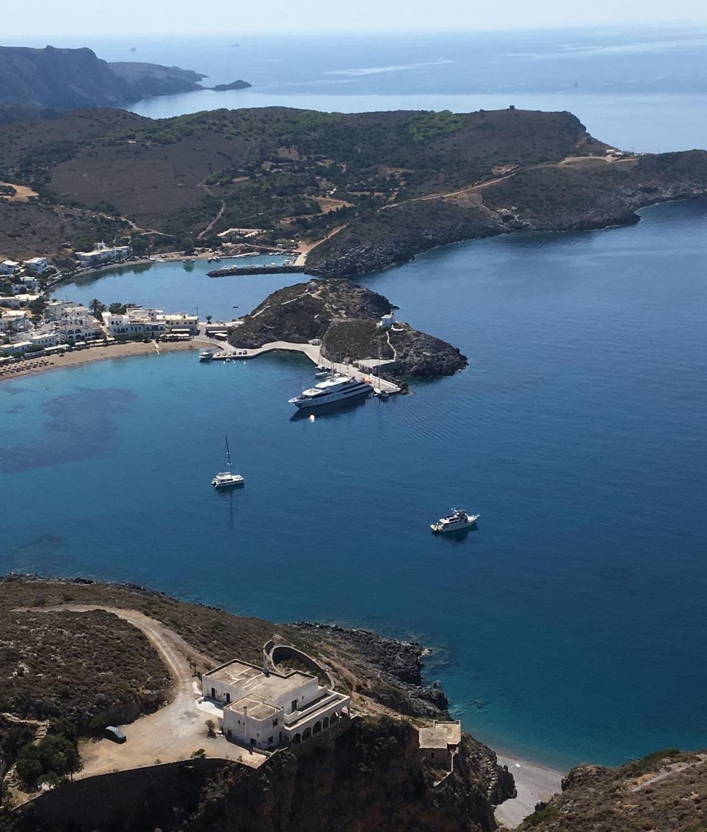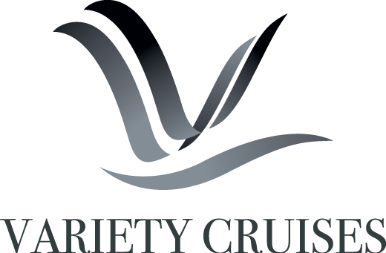
October 26, 2021

CLASSICAL GREECE 2022
ABOARD THE 25-CABIN MEGA YACHT HARMONY V
APRIL - OCTOBER 2022 | 8-day cruises Fridays - From Athens to Athens, Greece

A cruise voyage unraveling the wonders of Classical Greece, through the Aegean Sea to the Peloponnese mainland.

Highlights include:
October 26, 2021

Santorini · Mykonos · Delos · Crete · Hydra · Nafplion · Monemvasia · Kea · Kythira

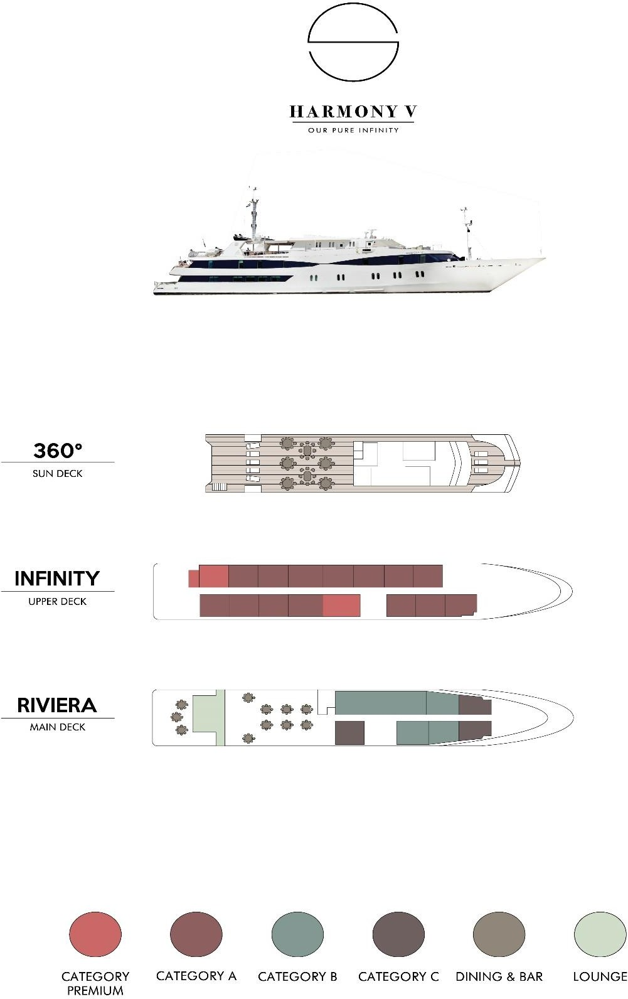
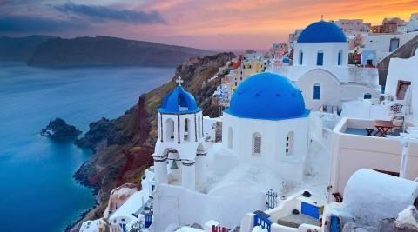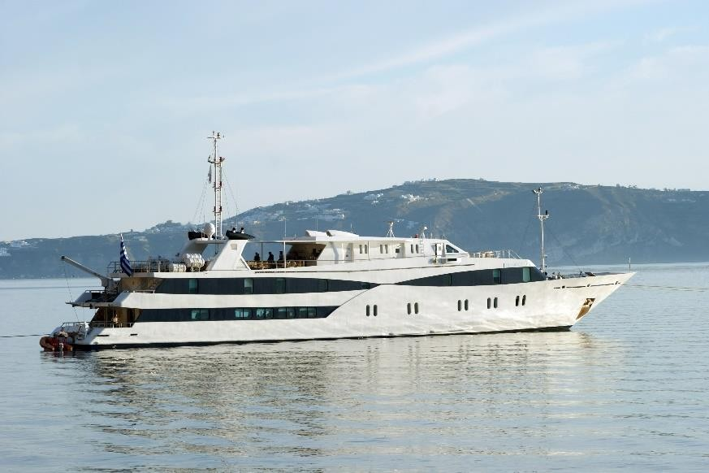
October 26, 2021

THE HARMONY V MEGA YACHT
The M/Y HARMONY V is a modern elegant yacht with a sleek high-tech look very similar to the private yachts to be found in the famous ports of the world.
GENERAL INFORMATION:
Length: 55 m
Rebuilt/Launched: 2009
Cabins: 25
Capacity: 49 passengers
Crew: 16-18

The M/Y HARMONY V is a 183 ½ ft-wide elegant yacht and was rebuilt/launched in July 2009. HARMONY V complies with EUROSOLAS safety regulations, ISPS (International Ships Port Safety Code) ISM, (International Safety Management), while its powerful engines, generators and state of the art stabilizers will allow for safe and comfortable cruising.
Service on board is provided by your Captain, the Cruise Coordinator and your experienced Marine and Hotel crew members. Service will be attentive or unobtrusive according to your requirements and priority is always given to the safety and comfort of passengers. Organized excursions are available for most ports of call and can be pre-booked or reserved 24 hours in advance.

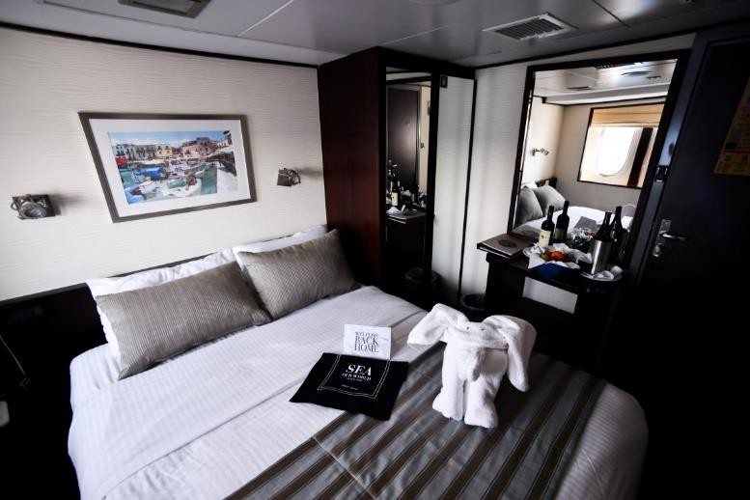THE MEGA YACHT HARMONY V
October 26, 2021

CABIN SPECIFICATIONS
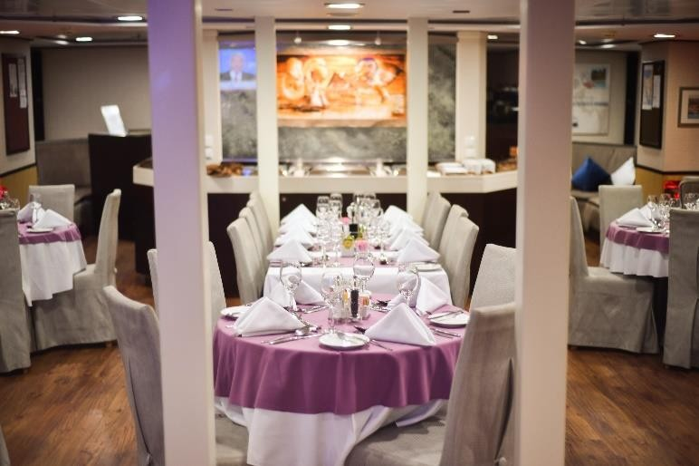
The 25 cabins of the M/Y HARMONY V are located on the Main deck (9 cabins) and on the Upper Deck (16 cabins). All cabins are premium and contemporary and are decorated with soft color furnishings. All 16 cabins on the Upper Deck offer flexible bedding configuration, which can be set to offer either two twin beds or a double bed. All cabins offer large windows and ensuite bathrooms with shower and elegant Corian finishing on walls and floors. Each cabin is equipped with flat- screen TV, DVD player, mini-fridge, hairdryer, individually controlled A/C, and safe deposit box.

LIFE ON BOARD

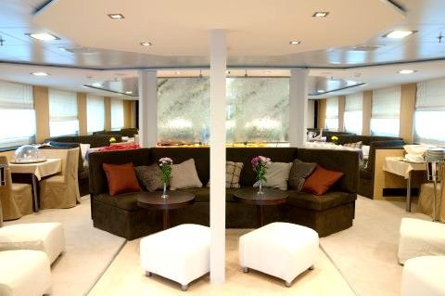
During the day, life on board centers around the Bar Lounge and Dining Room at the Main Deck and meals are also served “al fresco” depending on the weather and the ship location. The Mega Yacht accommodate all guests at one single seating and provide a high standard of cuisine, always with some local flavor. The classy dining room is surrounded by large windows providing beautiful views of the ports of call. The Sun Deck is the ideal place to bask under the sun, read a good book or just gaze at the scenery.

MAIN DECK LOUNGE & DINING ROOM
The classy dining room is surrounded by large windows providing beautiful views of the ports of call. The spacious dining room seats all passengers in a single, unassigned seating and food is served at the table or displayed on the state of the art hot & cold buffet which also includes an “a la minute cooking” section.

SUNDECK
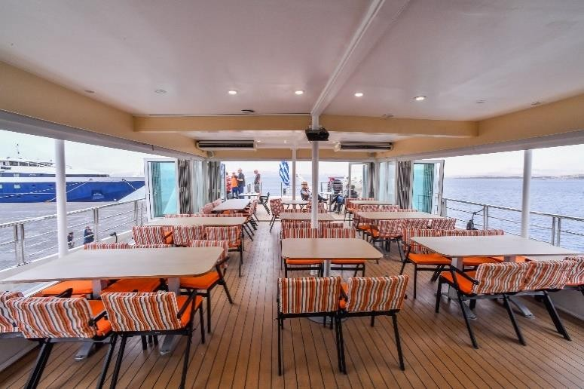
OUTDOOR/INDOOR DINING ROOM & LOUNGERS
Located on the Upper Deck, the outdoor dining area, also convertible into indoor area provides beautiful views of the ports of call visited and meals are served alfresco weather permitted. Sun loungers are available to bask under the sun, read a good book or just gaze at the scenery.
October 26, 2021

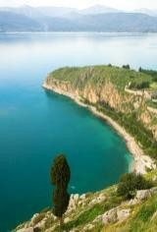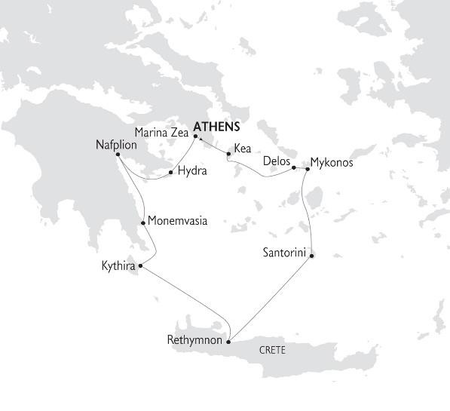Cruise Highlights include:
r • Santorini with her famous sunsets, sugar cube villages and the historical site of Akrotiri
Octobe
26, 2021
- Mykonos, the queen of the Aegean and nearby Delos, Apollo's sacred island, a breath-taking open-air museum and UNESCO World Heritage site.
- Hydra, a truly authentic, unknown island.
- Crete, the largest island in Greece.
- Monemvasia, a “stone about to set sail”

CLASSICAL GREECE CRUISES 2022 ON THE M/Y HARMONY V
FRIDAY DEPARTURES · 7-NIGHTS/8-DAYS · FROM ATHENS TO ATHENS, GREECE

DAY 1-
FRIDAY

ATHENS- KEA GREECE
Embarkation at Marina Zea in Athens, between 2-3 pm. Enjoy a welcome drink and meet your crew and fellow passengers. Depart via Cape Sounion to Kea. Time at leisure to explore Kea’s tiny port, Coressia after dinner. Departure in the early hours for Delos. Overnight at sea.

DAY 2 –
SATURDAY
DELOS- MYKONOS☽ GREECE
Optional morning tour to the unique archaeological site of Delos, antiquity’s most sacred island. On to the port of Mykonos, with a swim stop on the way. Free afternoon and evening to enjoy the island’s cosmopolitan lifestyle. Overnight in Mykonos.

DAY 3 –
SUNDAY

DAY 4 –
MONDAY

DAY 5 -
TUESDAY

DAY 6 –
WEDNESDAY

DAY 7 –
THURSDAY

DAY 8 –
FRIDAY

SANTORINI
GREECE

RETHYMNON CRETE GREECE

KYTHIRA☽
GREECE

MONEMVASIA- NAFPLION ☽, GREECE

NAFPLION - HYDRA - MARINA ZEA- ATHENS ☽, GREECE
MARINA ZEA- ATHENS GREECE
Early morning sailing and noon arrival in Santorini (anchorage at Fira). Experience the stunning natural drama of the volcanic caldera. Optional tour to archaeological sites and typical villages with unique views over the Aegean Sea. Overnight sailing to Crete.
Morning arrival at Crete’s famous and lively port of Rethymnon. Optional tour to the ancient city of Knossos near Heraklion. Late departure for Kythira. Overnight at sea.
Late morning swim stop and afternoon arrival to Kythira, a less known island gem now fast becoming a favorite among visitors to Greece. Evening at leisure to visit the picturesque main town of Chora and experience the subdued charms of this peaceful island. Overnight in Kythira.
Early morning sailing to Monemvasia. Discover a remarkable medieval fortified town, with time at leisure to explore the uniquely preserved Byzantine and Venetian architecture and experience the beauty of the natural setting. Depart for Nafplion in the early afternoon, with a swim stop on the way. Evening arrival at Nafplion. The old quarter is charming, with narrow streets and characteristic period architecture. Also, impressive medieval fortifications can be seen in the port and crowning the hills above. Overnight in Nafplion.

Optional tour to Mycenae, the powerful walled palace of Agamemnon, the Homeric Achaean king. Early afternoon departure for the island of Hydra. Time at leisure to explore this picturesque port town. Captain’s Farewell Dinner. After midnight arrival at Marina Zea, Athens.

Disembarkation at 9:00 after breakfast.

☽OVERNIGHT IN PORT

Itineraries can be changed at the discretion of Variety Cruises and of the Vessel's Captain in case of adverse weather conditions - winds of 6/7 Beaufort or more depending on the vessel- on port authorities not allowing a vessel to leave port or in case of other extraordinary conditions. Such itinerary changes do not automatically entitle passengers to any refunds, but Variety Cruises guarantees that passengers are disembarked at the advertised port of disembarkation on time for their flights.

October 26, 2021

CLASSICAL GREECE CRUISES 2022 - SAILING DATES
From Athens, Marina Zea  Friday Sailings | Apr: 22*. 29  May: 06, 13, 20  June: 03, 10, 17, 24  July: 01, 08, 15, 22, 29  Aug: 05, 12, 26  Sep: 02, 09, 16, 23, 30  Oct: 07, 14, 21, 28

*VALUE DATES DISCOUNT
-10% ON ALL CRUISE FARES FOR THE STAR-MARKED SAILINGS.
VALUE DATE DISCOUNT IS COMBINABLE WITH EARLY BOOKING DISCOUNT.

###

